Applying the Bra-ket interchange rule to (7.01) yields

.

Exchanging  and , we determine the outer product **action on bra vectors**:

. (7.02)

Notation. Suppose . To write the outer product linear operator  as a matrix, set . Then

 : (7.03)





Thus,

. (7.04)

Observe that the pattern approach used to write tensors in matrix form also works for outer products. Since ,

. ✔

Example. Confirm that the matrix outer product (7.04) agrees with the outer product definition (7.01).

Solution. Let. Then



and

 ■

Definition. If  is a normalized vector, is called **a projection operator**.

Observe that if  is a vector then  is a vector proportional to . We say  **projects  onto .**

Definition. Let *L* be an operator. The **trace of *L*** is

, (7.05)

the sum of the diagonal elements.

Theorem 7.1. Let  be a projection operator.

1. *L* is Hermitian
2. ** is an eigenvector of *L* with eigenvalue +1
3. If  is an eigenvector of *L* with eigenvalue 0.
4. The only eigenvector with unit eigenvalue is .
5. .
6. .
7.  (7.11)

(i.e., the sum of all projection operators for a given basis is )

1. ** (7.12)

(the expected value of an operator *M* in state is the trace of the product of the projection operator and the operator *M*.)

Proof.

1. By 7.03, . So . ✔
2. Since . ✔
3. Since . ✔
4. If  is a vector such that , then  where . That is,  are the same eigenvector because any multiple of an eigenvector is considered to be the same eigenvector. ✔
5.  since  is normalized. ✔

1. . ✔
2. Let  be any vector. Then



and similarly . Therefore . ✔

1. Let . Then . Therefore  ■

Definition. Suppose there are several states  and that Alice has prepared her system in state  with probability . We define **Alice’s** **density matrix** as the operator

 (7.12a)

and we say the **density matrix represents a mixed state**. When the density matrix represents a single state ,  is simply the projection operator,

 (7.12b)

and Susskind says "**Alice's state  is pure"**. I find that confusing. It says that if exists it is pure. One can't ever say that  is mixed. A better definition is that **Alice's system is pure** if a state vector  (or, equivalently, a wave function  ) exists. In that case ** is the projection operator of equation 7.12a).

Theorem 7.2. Let *LA* be any observable of Alice's system.

(a) Show for a mixed state that Alice’s expectation is

. (7.13)

(b) Let  be a basis for the Hilbert space of Alice’s states, and denote  and  in this basis. Show that  can be expressed

 (7.14)

Proof. Had Alice prepared her system in a single state  then she would have computed . So, for a mixed state, she computes



 ✔

In the basis , . That is, the element of  in row  and column  is . The diagonal element in row  and column  is  Thus, is the sum of the diagonal elements of . Finally,  ■

Note: The  matrix  is a sum of *r* terms. The sum does not appear in (7.14). However, it can be seen if we use the basis to turn into a matrix:

Define . (i)

Then

 (ii)

where

.

That is

 (iii)

So

 (7.12c)

That is

 (7.12d)

Definition. **A pure composite system** is one in which there is a state vector (or, equivalently, a wave function ). If there is a distribution of possible starting states, we say that AB is **mixed.**

If AB is pure we say that **Alice knows the wave function**  (and also the composite system state ).

Exercise. Suppose Alice and Bob have single-spin systems and Alice selects an observable *LA* of her subsystem A. *LA* has no effect on Bob’s subsystem B. Find the operator *L* in the composite system AB that represents *LA*. If AB is pure, find Alice's expected outcome .

Solution. We use the  basis . An element of *LA* in row *a*' and column *a* is .Thus,

.

Similarly an element of *L* in row *a’b’* and column *ab* is . Thus,

135 .

Keep in mind that the 1st and 3rd subscripts pertain to Alice and the 2nd and 4th pertain to Bob.

Because Alice’s observation does not affect Bob’s states,

 .

Also, the half of the elements, like , that represent a change in Bob's state must equal zero and the remaining elements that leave Bob’s states unchanged must equal the corresponding *LA* element. For example,  equates to . We represent this mathematically as

 (7.18)

where on the RHS  captures Alice’s observations and  captures whether or not Bob changes states.

We replace the elements of *L* using (7.18), carefully managing the subscripts because they are in a different order on each side of (7.18):

.

If we then set

,

we have

. ✔

Now, suppose AB is pure. Then there is a state vector . Let be the eigenvectors of *L*. Then forms a basis for AB by the Fundamental Theorem and also by Exercise 3.1. Hence, we can express as

.

So

,

and

.

We are now set up to compute Alice’s expected outcome. To compute , notice that in general if  and , then

.

So by letting  we get that

 (7.15)



 (7.19)

. (7.19b)

**Define a density matrix **:**

  (7.17)

Then

 (7.21)

is the same as equation (7.14) in which ** represented Alice's density matrix for a mixed state . Thus, even though AB is pure, A must be described as a mixed state. We will quantify just how "mixed" A is shortly.

To generate the other expression, (7.13), for we denote Alice's density matrix as . Then

 (7.20b)

and

.

Noticing that this expression is the sum of the diagonal of , as shown in (7.20b), we obtain . ■

To calculate Alice’s density matrix , she may have had need of the composite wave function. But once she has  she can forget where it came from and use it compute anything about her observations.

Theorem. Let ** be Alice’s density matrix in the pure composite system per equation (7.17). Show that the probability that Alice’s system will be left in state *a* after a measurement *LA* is performed on her system is

 (7.22)

Solution. The operator  is the composite state representation of *LA*.

Letting be a basis for B we can write since forms a basis for AB. From Principle 4, (3.11), . So

 ■

Note.  is a diagonal element of **. So the diagonal elements are probabilities.

Theorem 7.3. Alice's system is pure iff the composite wave function  factorizes (i.e., ). In this case Alice's wave function can be expressed

 (7.25)

Proof. Suppose . Then  are the states of Alice and Bob, respectively. Then

. ✔

By (7.12b), the RHS contains the elements of the projection operator . Thus,  and, by definition,  is pure since it is just one state.

Conversely, suppose A is pure. Then there is a state vector . So

.

By definition (7.17), for a composite system, . So

.

This represents  equations (i.e., ) in  unknowns (i.e., ). Clearly  is a solution. Thus,  factorizes. ■

Definition. If the composite wave function does *not* factorize, we say that AB (and Alice and Bob) is **entangled.** It is **maximally entangled** if all of Alice's (and Bob's) probabilities P(*k*) in equation (7.12a) are equal.

If A is entangled, then Alice does not have a state space. That is, AB is entangled implies A is mixed.

Summary – What Alice knows about her system and the composite system

when AB is pure

* Alice knows the most she possibly can about the composite system because she knows composite state vector .
* As to her own system, at one extreme, if  factorizes, then from Theorem 7.3 her system is pure. She knows her state vector . Alice has complete knowledge of her system because , a product state.
* On the other hand, if  is maximally entangled, she knows nothing of her state (because all outcomes are equally likely) though she has maximum information about AB. Einstein had difficulty accepting this.

Example. If the composite state vector is a singlet or a triplet, then AB is maximally entangled.

Proof. We must show that all of Alice's probabilities are equal; that is, .

Suppose  . Then . Thus,

.

Using  we get

,

,

,

.

So . Thus, AB is maximally entangled.

We showed in Exercise 7.8(b) for  that  and we can similarly show this for . ■

We next prove the footnote on p. 108 that states that any Hermitian matrix can be diagonalized by a change of basis. There are insights to be gained, including the corollary to the theorem.

Theorem 7.4. If *M* is an *n* x *n* Hermitian matrix, there is a unitary matrix *U* such that  is a diagonal matrix having the eigenvalues of *M* on its diagonal.

Proof. Because *M* is Hermitian there is an orthonormal basis  of eigenvectors of *M*. Let *U* be the matrix whose columns are the eigenvectors:

. So .



which implies that the *i* *j*-element of , row *i* of  times column *j* of *MU*, is

.

 . ✔

*U* is unitary because

. ■

Corollary. Let ** be Alice's density matrix in a pure composite system AB, and denote the eigenvalues of ** by . Let *U* be the matrix whose columns are the eigenvectors of **. Then  is also a density matrix as well as a diagonal matrix whose diagonal entries are .

Proof. Let  denote the bases for Alice, Bob, and the composite system, respectively. Since AB is pure, there is a state vector

, (a)

and by definition (7.17)

 where . (b)

Let  denote the set of eigenvectors of **. It is another basis for Alice. As defined in Theorem 7.4,

. (c)

or

 (d)

Since *U* is unitary,

. (e)

By Theorem 7.4,  is a diagonal matrix with the eigenvalues of ** on its diagonal:

. ✔ (f)

In order to show that  is a density matrix we must find a wave function  such that . Since  is a basis for A we can write  or equivalently . This represents *n* equations in *n* unknowns:



  (g)

Define  and .

Then (g) can be written in matrix notation as

  

 

 .

That is,



or

. (h)

We can use (h) to write the state vector in terms of the basis  and then collect the  terms to define .

. (i)

Define

. (j)

Then

,  (k)

 (l)

and

. (m)

Claim :







 

, which proves the claim. ✔

This means that  is a density function. ✔

Finally, because  is a density function,  ■

Lessons Learned about ** and  : Diagonal elements of ** are { P(*a*) }, diagonal elements of  are {}, and  is a probability but not generally equal to P(*a*). Also, Theorem 7.5, below, proves that  = 1.

Theorem 7.5. If *A* and *B* are matrices then Tr *AB* = Tr *BA*.

Proof.  and . So

.

(*) Replace *i* by *k* and *k* by *i*. ■

Theorem 7.6. Let  be the wave function for a pure composite system AB, and let ** be the density matrix for system A.

1. ** is Hermitian
2. (Exercise 7.6) Tr (**) = 1
3. If ** is an eigenvalue of **, then 0 ≤ ** ≤ 1
4. If any eigenvalue equals 1 then all the others are zero
5. For a pure state A, 
6. For a mixed or entangled state, A, 

Proof.

1.  Thus,  and  ✔
2.  ✔
3. From the Corollary to Theorem 7.4, ** is a probability. ✔
4. By (b) and (c), if one diagonal element ** = 1, then the rest are zero. ✔
5. From Lessons Learned in (c),  is a diagonal matrix of the eigenvalues of ** and . For ** to represent a pure state, some  and the rest are 0 since only one state  is observed. [ is the probability that state  is observed.]

.

Thus, . Since  we have

 (i)

and

. (ii)

So

. ✔

Thus,

. ✔

1. For an entangled state, Alice has 2 or more non-zero eigenvectors, so the diagonal of  has at least two non-zero elements, and due to (b) and (c),

each  satisfies . Therefore  

  ✔

and

 ✔ ■

Theorem 7.7. Suppose Alice's density matrix ** represents a pure system with state vector . Then

1.  is an eigenvector of ** with eigenvalue +1
2. If  then  is an eigenvector of ** with eigenvalue 0
3. ** has exactly one non-zero eigenvalue **, and ** = +1

Proof.

1. Since  is pure, by Theorem 7.3 . So





 ✔

1.  ✔
2. By Theorem 7.6 (d), if any eigenvalue is 1, all the others are 0. ■

Corollary. If the state vector  of a composite system is a product state vector, then (a–c) above hold.

An example of the concepts of the past few pages is helpful: Alice and Bob state vectors, wave functions, observables and expected values; the density matrix and a change of basis to diagonalize it; the product state and wave function; and correlation of the observables.

Example.

Given

* A state space basis of for both Alice and Bob,
* Alice's system is prepared in the direction



* Bob's system is prepared in the generic direction



* Alice and Bob measure spin along the *z*-axis
* The composite system is a product state

Compute/Identify

* Find Bob's state  and wave function, observable  and its eigenvectors and eigenvalues, and use equation (4.13) to compute 
* Find Alice's state, wave function, observable, eigenvectors and eigenvalues, and compute .
* Find Bob's density matrix , confirm that it is the projection operator, and compute .
* Find the unitary matrix *U* of Theorem 7.4 such that  is a diagonal matrix and use it to help show in 4 different ways that Bob's system is pure
* Find similar information for Alice's density matrix
* Find the product state  and the wave function
* Show that Alice's and Bob's observables are uncorrelated

Solution.

**Bob**

Bob's state  is used to measure spin in the *z*-direction. Thus, equations 1.01, 1.02, and 2.2 apply:

,

,

.

A general solution for  is

, .

The phase factor  must be included or else   .)

The general expressions for  are  and :

 ✔

 in the orthonormal basis of its eigenvectors . The corresponding eigenvalues are +1 and -1. So, the conditions for equation (4.13) hold, and





Check #1:  ✔

(definition of expected value)

Check #2:  (cosine of angle between prep and measurement) ✔

Bob's wave function is .

**Alice**

 From Bob's generic results we deduce that . (Alice's phase factor is zero because .) Also, , , and . Thus,  and her wave function is .

**Density Matrix**

Bob's density matrix is  :

.

Therefore



Check: . ✔

Claim:  is the projection operator :

 ✔

Also

.   ✔

Even though the formula above for  in Theorem 7.2 pertained to mixed systems, it is true also for a pure system, like this one, because pure is a special case of mixed where P(*a*) = 1 for one state *a* and P(*a*') = 0 for all other states *a*'.

We next diagonalize  and confirm that its diagonal entries are the eigenvalues of . (We would also diagonalize  but it is already diagonalized and we observe that its diagonal entries are indeed its eigenvalues.)

We begin by using the characteristic polynomial  to find the eigenvalues of :



.

We find the eigenvectors of  by solving , resulting in

 and .

Let *U* be a unitary matrix whose columns are the eigenvectors of :

 .

Then

.

So

.

Thus,  ✔

We show below in four different ways that Bob's system is pure:





 ✔

 ✔

 ✔

 ✔

Plugging Alice's values into Bob's generic formulas yield

.

So

.

**Composite System**

The product state is the tensor product

.

The product state wave function is

.

**:**













Therefore   ✔

As expected,  are uncorrelated. ■

Note 1. Exercise 7.9 is practically a subset of this exercise except that Alice's as well as Bob's state is generic.

Note 2. Had the system been prepared in the *z*-direction and measured in some direction  (instead of vice-versa), the problem would essentially be the same but we would not have been able to use key formulas like 2.2 [], 4.13 [], or 7.13 []. That is, care must be taken to measure spin in the *z*-direction to use many of the formulas in the book.

We saw in Bob's generic system that his density matrix  has one eigenvalue +1 and the other 0. The following theorem confirms this behavior.

Theorem. Let  be a composite product state where  and  are unit vectors. Then Alice's density matrix ** has one eigenvalue  equal to 1 and (*n* – 1) eigenvalues of 0, where *n* = , the dimension of Alice's space of states. Moreover .

Proof. The composite state AB is pure because  exists. By definition (7.12b) for a pure state, ** is just the projection operator:

.

If ** is an eigenvalue of ** with eigenvector , then . So

. (K)

Extend  to an orthonormal basis  for . Set  for *k* > 1. Observe that

,

so  is an eigenvector of ** with eigenvalue . Observe for *k* > 1 that



so that  is an eigenvector of ** with eigenvalue *k* = 0. ■

Summary – What Alice knows about her system and Bob's system if the composite system is pure

* Alice knows the wave function of the composite system AB since it is pure
* At one extreme, if the composite state is a product state (i.e., not entangled) then
  + Alice knows everything about her own state, namely the probability of each possible outcome.
  + But she has no knowledge of Bob's system since the two systems are uncorrelated.
* At the other extreme, if the composite state is maximally entangled, then
  + Alice knows nothing about her own state because the probability of one outcome is the same as any other
  + But after she performs a measurement of her state she knows everything about Bob's state because the two states are fully correlated. For example, if Alice measures up then she knows that Bob will measure down.

**Section 7.8 Quantifying the spin measurement apparatus** **A**

We assign the **spin apparatus A** three states.

 = Blank = Read-out in apparatus window prior to a measurement

 = Read-out of +1

 = Read-out of -1

Alice's states are .

The basis for the composite system (consisting of Alice plus the apparatus) is



Let *L* be the apparatus Hermitian measurement operator, defined as

 (i)

After a measurement, if **A** reads +1 then the spin is up and if it reads -1 then the spin is down.

If the initial spin is in a superposition state  then

, (ii)

an entangled state where P(+1) = . It is maximally entangled if in the singlet state of . Moreover, over time the system evolves via a unitary operator U operating on the initial state .

Interestingly, even though *L* has been defined on only 2 of the 6 basis vectors, this is enough to completely determine the matrix of *L* in that basis.

First, equations (i) requires that row 1 (see below) have 1 in position (1,2) and zeros elsewhere and row 4 have a 1 in position (4,5) and zeros elsewhere.

To fill in row 2 I assume we want *L* to generate the apparatus' behavior when the on-off button is pushed after system AB is prepared in state . If the first push of the button put us into this state, then a 2nd push of the button should turn off the apparatus but not interfere with the spin state. That is we should put 1 in position (2,1) and zeros elsewhere in row 2. Similarly, we should put 1 in position (6,4) and zeros elsewhere in row 6. Notice that (2,1) and (6,4) would be 1 at any rate because *L* is Hermitian.

If we fill in the conjugates of the elements defined thus far, the matrix has all zeros and ones except it is yet to be defined at positions (3,3), (3,5), (5,3), and (5,5). The values don't matter since the states  and  can never be obtained. The simplest solution is to define (3,3) and (5,5) to be 1 and (3,5) and (5,3) to be 0. That is, starting in either of these states is means staying in the same state.

That completes the matrix *L*. It satisfies (i) and (ii). For a general initial state we have

.

Returning to entanglement and collapse, at first the apparatus knows the spin state and is entangled, but not Alice. Alice knows the spin state after she looks at the apparatus and she then becomes entangled. For Alice, the spin wave function has collapsed. From Bob's perspective the system has not collapsed; it is just a 3-way entangled system (spin, apparatus, Alice).

Thus, an entangled entity observes a particle while an unentangled entity experiences a wave. As in Special Relativity where there is no contradiction that two observers see a different speed for an object, there is no contradiction that entangled Alice sees a particle yet unentangled Bob sees a wave.

We next further clarify this in terms of locality.

**Section 7.9 Entanglement and Locality**

Definition 1 of **locality**. A system is **local** if no information can be sent faster than light.

Extend Alice’s system A to contain her measuring apparatus and Alice herself, and the same for Bob’s system B. Let  be a basis for A and  be a basis for B. Then  is a basis for AB. Let be the composite system wave function, possibly entangled:

.

Alice’s complete description of her system is contained in her density matrix **:

 (7.31)

We will show there is nothing Bob can do to instantly change **, thus proving that even if AB is maximally entangled, no faster-than-light signal can be sent by Bob to change Alice’s system. That is, quantum mechanics does not violate “locality” per definition 1.

Bob’s system, including any changes he makes, must be described by a unitary matrix:

.

The corresponding unitary matrix for the composite system is



.

When U acts on the initial wave function it creates a new, or final, wave function



. (7.32)

Changing , the corresponding bra vector is

. (7.33)

Also

.

So



. (7.34)

Then Alice’s final density function is







 ✔

So nothing Bob does affects Alice’s density function.

However, … if Bob collapses his wave function, then at the moment Alice collapses her wave function she instantaneously *receives* information about the state of her system, but that information is *not sent* (at least, not by Bob). This suggests a second definition of locality, alluded to by Susskind but never stated. The definition below is my idea.

Definition 2 of **locality.** A system is **local** if no information can be *received* faster-than-light.

We have just shown that although quantum mechanics is local with respect to definition1, it is non-local with respect to definition 2.

**Sec****tion 7.10 Bell's Theorem**

We next develop Bell's Theorem and then consider it in terms of the two definitions.

Example 1. Entangle 2 particles to have opposite spins. Let Alice and Bob make repeated spin measurements in the directions 0°, 120°, and -120°, each choosing directions randomly. Compare their first measurements, then their 2nd, …. Find the expectation that compared spins are in opposite directions.

Solution. Suppose Alice measures +1 (in one of the directions). When Bob randomly chooses his direction, there is a 1/3 chance he picks the same direction as Alice and 2/3 chance he picks a different direction. If he chooses the same direction, then his result is -1 since the particles are oppositely entangled. That is,

.

If he chooses a different direction than Alice, then for Alice in this direction,

.

So,

.

Thus,

.

The calculation is the same if Alice measures -1. Thus, E(opp) = . ■

In the next example, the doors represent directions, the color blue represents +1 spin, and red represents -1 spin.

Example 2. Suppose there are 3 doors and behind each door are 2 colored balls. Two of the doors have a blue ball in front and a red behind, and the other door has a red ball in front and a blue ball behind. Alice and Bob each randomly select a door. Alice always selects the ball in front and Bob always selects the ball in back. Find the expectation that the balls selected are different colors.

Solution.

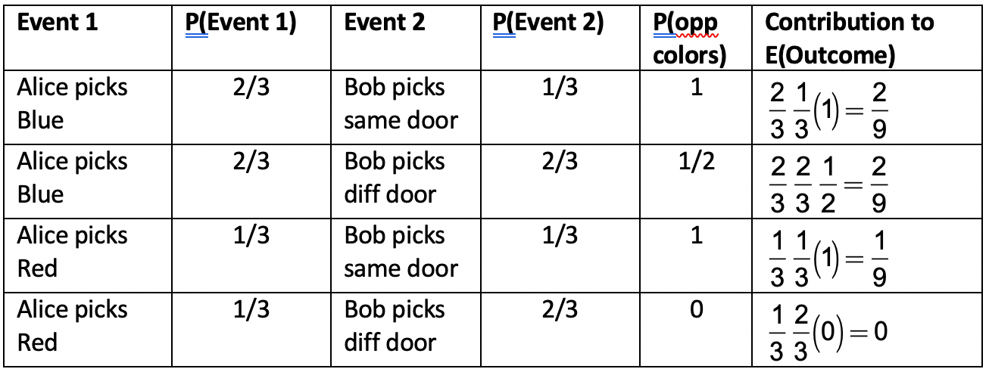

E(opposite colors) ■

The issue being investigated in examples 1 and 2 above is whether or not entangled particles have a definite spin prior to being measured. Einstein and Bohr famously argued about this but since the calculated result of a single measurement is the same under either assumption, they thought this to be simply a philosophical disagreement. However, years later Bell generated examples like the two above that show there is indeed a measurable consequence for each assumption.

Suppose the particles do have a definite spin prior to measurement. If the front balls are all blue (or all red) then E(opposite color) = 1. So, suppose there are balls of both colors. There must be 2 blue balls and 1 red, or vice-versa. Example 2 proves that E(opposite spin) = . Thus, no matter what, E(opposite spin) .

However, if the particles have no definite spin until the moment of measurement, then Example 1, which uses QM calculations, predicts that E(opposite spin) = .

Years after Bell developed his famous theorem, the technology became available to perform such an experiment. The measured result was ½. That is, it was found that particles do not have definite spin until the moment a measurement is made.

Theorem (Bell's Inequality). Two particles are entangled with opposite spin. They are repeatedly measured along axes chosen randomly and independently from 3 different directions. If they have definite spins (even if they are hidden values that we cannot access), then E(opposite spin) .

Example 3. A classical computer can simulate quantum spin.

Solution. We assume as usual there is an apparatus with a Measure Button and a Display Window that can be placed along any axis in 3-space. We imagine a classical computer that initially stores 2 complex numbers in memory,  that are normalized as usual by . The computer solves the Schrödinger equation to update the **'s. The computer also stores a unit vector representing the apparatus' 3D orientation. Finally, the computer stores +1 or -1 and displays the number in the Display Window.

Alice selects an orientation and pushes the Measure Button on the apparatus. The computer uses a random number generator to output +1 or -1 with probabilities  and , respectively. Then the Schrödinger equation takes over until the apparatus is (possibly) re-oriented and the button is pushed again.

There is no known experiment that Alice can perform to distinguish that the computer is not a quantum computer. ■

Example 4. A classical computer can also simulate a pair separated, entangled particles assuming information from the computer travels instantaneously to each apparatus. Thus, the computer is non-local with respect to definition 2 yet it is *local* with respect to Definition 1 because even instantaneous information from Bob about his wave function cannot affect Alice's density function (which encapsulates everything she can know about her system). Thus, Susskind makes the case that Bell's Theorem (and, also, the Einstein-Bohr argument) was about Definition 2 which describes a computer simulation and not about the real world.

Solution. Denote the composite system by

.

Let  be Alice's and Bob's respective measurement operators. Then  and similarly for Bob . For example, .

The computer initially stores 4 complex numbers:  and it updates them using the Schrödinger equation for the combined system. Alice's Display Window shows only her spin (+1 or -1) as does Bob's. Each apparatus can be independently oriented and each has its own Measure Button. When Alice pushes her button, the composite computer uses a random number generator to instantly display +1 or -1 on Alice's Display Window according to the probabilities , and similarly for Bob.

As in Example 3, there is no known experiment that Alice or Bob can perform to distinguish that this is not a quantum computer. ■

Example 5. A classical computer cannot simulate a pair separated, entangled particles if information from the computer travels to each apparatus at less than or equal to the speed of light. Thus, the combined system is local with respect to definition 2.

Solution. First of all, if the computer is situated, say, with Bob, then the slower-than-light updating of her Display Window is a clear giveaway to Alice that the computer is classical.

But perhaps part of the composite computer resides with Alice and part with Bob. They can now see instantaneous results in their Display Windows.

As usual let Alice's and Bob's system states be  and , respectively. Alice's part of the computer can only generate  and, similarly, Bob's part can only generate . The composite computer cannot instantly determine  as would be necessary if, say, the spins were entangled in the singlet state (opposite spins). The computer can only use  for Alice and  for Bob.

So, how do Alice and Bob figure out the computer is not a quantum computer? Suppose that Alice and Bob make a large number of measurements, independently and randomly choosing from directions 0°, 120°, and -120°. Since

the spins have distinct values, according to Bell's Theorem, E(opp spin) > . But, also according to Bell's theorem, a true quantum computer would yield E(opp spin) = . So, Alice and Bob are able to determine that the computer is not a quantum computer. (They could also just compare their spins and observe that half of them are not opposites.) ■

Note. In Example 4 we *currently* know of no experiment that distinguishes the computer. We know that Bell-like experiments are not sufficient but that is not to say that some clever person won't one day find a different experiment that does distinguish the computer.

**Chapter 8. Particles and Waves**

**TABLE 8.1**

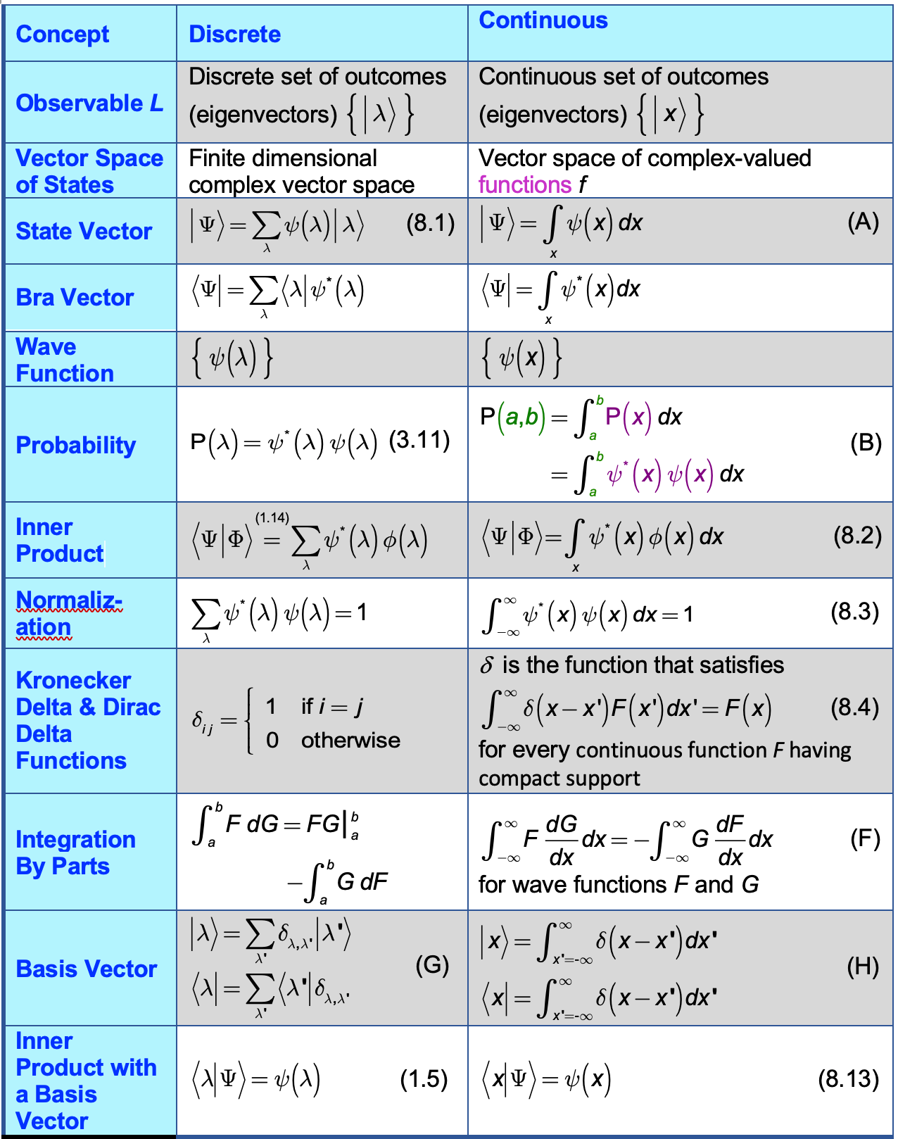

Quantum Mechanics is not so much about particles and waves as it is about the set of non-classical principles given in Chapter 3 that govern their behavior. We now extend the principles and concepts from the discrete systems we have so far studied to continuous systems (where we will at last develop wave examples.)

In Table 8.1, the values *x* could be points in  or even other types of more abstract spaces. For this book, however, it is sufficient to consider just the case where .

**Vector Space**

It is easy to show that all the conditions of a vector space hold if we define addition of two functions to be  and scalar multiplication by a complex number to be .

**Probability**

For the discrete case, if  is a basis for the state , then

 (8.1)

and

. (3.11)

For the continuous case, if  is a basis for the state , then

 (A)

and

. (B1)

Since P(*x*) is a density function, P can act on a (finite or infinite) interval:

. (B2)

**Inner Product**

Let .

The discrete form of the inner product is

. (1.14)

The continuous form is

. (8.2)



**Dirac Delta**

Definition. A function *F* has **compact support** if there is some closed interval [a,b] outside of which *F*(x) = 0.

In this book it is assumed that all wave functions are continuous and have compact support.

Intuitively the Dirac delta function  is a density function at some value *x*. In physics it is often defined informally as the function ** that satisfies:

 (8.4)

for every continuous function *F* having compact support.

The reason this definition is “informal“ is that there actually is no such function. We give a more rigorous definition shortly.

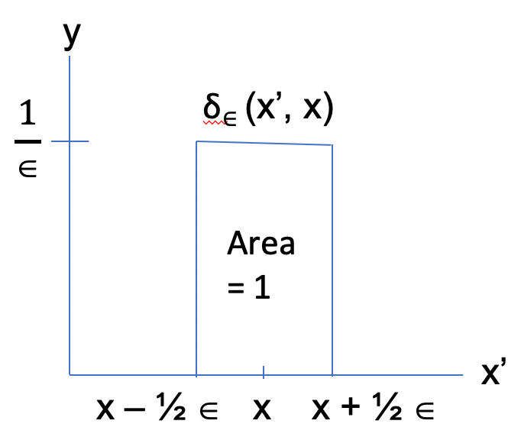

The Dirac delta function can also be visualized as the limit of a set of shrinking step functions of increasing height as follows.

For  define step functions

.

Then

 (C)

It is understood that the limit above cannot be freely interchanged with the integral sign. This, too, doesn't make sound mathematical sense since it violates Fubini’s theorem. In fact, we make the interchange when convenient, such as in (E), below.

It follows immediately from (C) that

: (D)

 ✔

and

: (E)

. ✔

When referring to equation (E) in light of (D), we informally say that **** approaches infinity at a rate that keeps the area under the curve  at unity.**

Since, by (E),  can equal infinity, ** is not a (real-valued) function. This is part of why the definition (C) does not make precise mathematical sense.

Thie informal definition (C)* *could also have been made in terms of the normal distribution density function instead of . To see this, let  and compare . The graphs below show the comparison for *x* = 1 and *n* = 20.

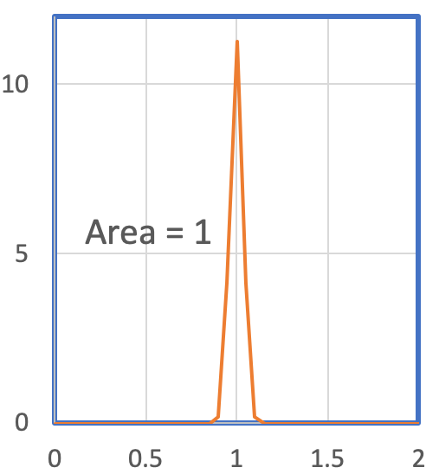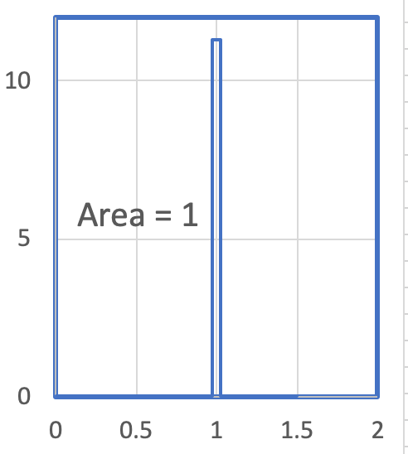

 

Unfortunately, the fact that the above definitions are informal and mathematically incorrect makes proving some of its properties difficult. See, for example, the argument below to normalize  in equation (8.17).

A mathematically rigorous definition of ** involves the concept of measure, specifically Lebesgue measure. The Dirac delta “function” is not a function at all but a measure. The argument of a measure, unlike a function, is a set. The Dirac delta function  is defined for any measurable set containing zero to be 1, and to be 0 for any other measurable set. The Lebesgue integral with respect to ** satisfies  or, by translation, , for any continuous function *F* with compact support. Note that the argument of ** is a set.

There is a cumulative distribution function associated with the density function ** 

 where .

So, ** is the derivative of ** but only in the sense that 

where these integrals are understood to be Riemann-Stieltjes integrals.

**Integration By Parts**

We are able to drop the term  because wave functions are zero at :

 (F)

**Inner Product with a Basis Vector**

Consider . When  is one of the basis vectors used in the definition of , the inner product takes a simpler form:

 (8.13)

This equation is needed in the derivation of equation (8.18), which Susskind leaves to the reader.

While equation (8.13) is perhaps an obvious generalization of the discrete equation (1.5) shown in Table 8.1, Susskind mentions that (8.13) holds because  is represented by the Dirac delta function. This is worth showing and adds a little more insight into (8.13).

In order to have a discrete process to imitate, we write the discrete basis vector in terms of the Kronecker delta:

. (G)

Then,

 (1.5)

In the continuous version of (G), the Kronecker delta is replaced by the Dirac delta and takes the form

. (H)

Equation (8.2) can be rewritten

 (I)

and so

. ✔

In other words, the wave function, , of a particle at position *x* is the projection of a state vector  onto the eigenvector of position.

**Linear Operators**

Recall that observables are represented by Hermitian linear operators. By definition, *L* is a **linear operator** if *L*(* x* + * y*) = * Lx* + * Ly*.

Recall that *L* is H**ermitian** if .

In the two examples below, * * is a complex-valued function of a real variable *x*.

Example 1. **Multiplication Operator**:  (8.5)







(because  since ).

Thus, by Theorem (3.06), *X* is Hermitian.

Example 2. **Differentiation Operator**:  (8.6)

 (8.7)



Thus, *D* is anti-Hermitian. But, we next show that this means that both *i D* and

- *i D* are Hermitian. In particular,  is Hermitian.

Theorem. If *M* is anti-Hermitian, then both *i M* and – *i M* are Hermitian.

Proof. Let . In particular,

 (i)

 (ii)

Let -complex matrix. Then

 (iii)

 (iv)

Suppose *M* is anti-Hermitian:

 (v)

Then

. That is, *i* *M* is Hermitian. ✔

. That is, -*i* *M* is Hermitian. ✔      ■

**Eigenvectors and Eigenvalues of the Multiplication Operator: Position**

The multiplication operator *X* is the Hermitian operator that represents the position observable. That is, a position is simply a number on the *x*-axis, and multiplication by any real number is possible. So, an outcome of *X* is a real number, a position.

Let  be a state vector for the observable *X*, and  an outcome. By Principle 2, an outcome is an eigenvalue of *X*. That is,

.

By the definition (8.5) of *X*, the LHS is

.

The RHS is

.

Thus,

 a.e. (almost everywhere; i.e., except on a set of measure

zero)

  a.e. (8.11)

This means that except on some set of measure zero, if .

We seek a function  that has the property (8.11) and that also satisfies the normalization requirement:

. (8.3)

We claim that the Dirac delta function meets these conditions. Let

 (J)

If . Thus,  satisfies (8.11). Also

.

So, intuitively  satisfies (8.3):

,

This argument lacks rigor because we haven’t shown that  is just infinite enough that the area under the curve is unity.

Definition. We will refer to  as the **wave function in the position representation**.

**Eigenvectors and Eigenvalues of the Multiplication Operator: Momentum**

We move on to the concept of momentum. The **momentum operator** is defined in terms of the differentiation operator:

. (8.14)

Plugging in the definition of *D* gives

 (8.15)

The  factor is needed to provide units of momentum (mass times velocity).

Experiment has shown that we cannot simultaneously measure position and momentum. A state



can be expressed in term of either position or momentum. Of course, the momentum wave function will be different than the position wave function. If we label the momentum wave function , then the state  written in terms of momentum is:

. (K)

Since  is one of the basis vectors in equation (K), formula 8.13 applies:

. (8.20)

We are now set to develop the equations that transform back and forth between  and .

Step 1. Since a momentum eigenvector  can be considered to be a state of *X*, it can be written in terms of the  basis. It will have its own wave function that we will call . That is,

. (L)

We combine this with equation (H) to get

. (M)

Step 2: Since is an eigenvector of *P*,

.

LHS: .

RHS: .



Solving the differential equation yields

 a.e.

To solve for *A* we must apply normalization, but (8.3) doesn’t work:

.

I believe the problem arises from the incorrectness of the informal Dirac delta definition. An approach that apparently works is to first assume that *x* is periodic with period . This leads to discrete values  for *p* and use of the discrete normalization equation in Table 8.1, above. Then taking , discrete  continuous *p*, and Kronecker **  Dirac **, this finally leads to

.

Thus,

 a.e. (8.17)

Therefore

 (8.18)

Step 3. For a discrete basis,

. (8.21)

The continuous versions of this are

 (8.21)

and

 . (8.22)

Thus,

: (8.24)

 ■

Example. Alice measures the position wave form  of some particle and she wants to know the probability that she would have measured momentum *p*.

Solution. First, she calculates . Then . ■

Solving for  in terms of  is very similar.

: (8.25)





Equations (8.24) and (8.25) are **reciprocal Fourier transforms**, and are the central equations of Fourier analysis.

**Heisenberg Uncertainty Principle**

Let  be either a position or momentum wave function. By definition,



and

.

So,



,

or

. (8.29)

In classical physics, *X P* – *P X* = 0, but not in quantum mechanics where we see from (8.29) that the commutator is not zero. By the Simultaneity Principle developed in Chapter 5, this means that *X* and *P* cannot be simultaneously measured. In fact, the Heisenberg Uncertainty Principle provides a floor for the uncertainty.

Recall that we denote the uncertainty of an operator by its standard deviation.

is the **standard deviation of *X*,**

****is the **standard deviation of P.**

When we apply the Heisenberg Uncertainty Principle developed in Chapter 5 to *X* and *P* we get

:

.

No matter how cleverly we measure position and inertia, we can never drive the uncertainty below this small quantity.